Github link :

<https://github.com/Ranjeet-Waghmode/pro1234>

tinkercad simulation

<https://www.tinkercad.com/things/gY7AZ48yXZQ/editel?returnTo=%2Fdashboard%2Fdesigns%2Fcircuits&sharecode=KopxZ0IeZOQJX739y-c9Cbg-0yVHGmhb3_toLmWuPjA>

all related files are shared in the repo

.BRD, picture ,electronic component list and all ..

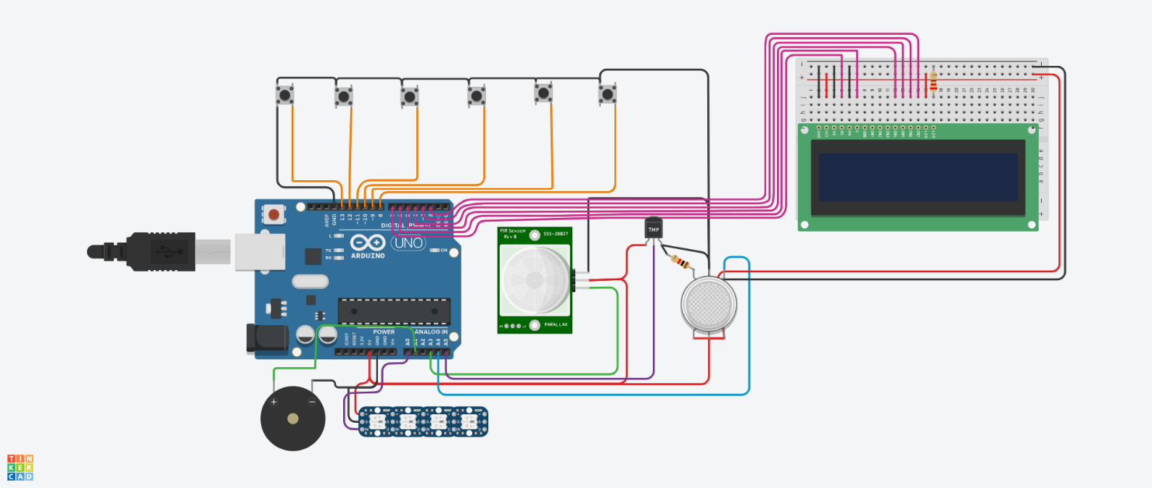

Component list file name is

component.csv

Arduino Code :

#include <Adafruit_NeoPixel.h>

#include <LiquidCrystal.h>

// Pin Definitions

const int frontLeftDoorPin = 13;

const int frontRightDoorPin = 12;

const int backLeftDoorPin = 11;

const int backRightDoorPin = 10;

const int frontBonnetPin = 9;

const int backTrunkPin = 8;

// Temperature sensor pin (LM35) - Now at A5

const int tempPin = A5;

// Gas sensor pin (analog input)

const int gasPin = A4; // Gas sensor connected to A4 pin

// PIR sensor pin

const int pirPin = A3; // PIR sensor to detect motion

// Debounce-related variables

unsigned long debounceDelay = 50; // 50ms debounce delay

unsigned long lastDebounceTime[6]; // Store debounce time for 6 switches

int lastButtonState[6] = { HIGH, HIGH, HIGH, HIGH, HIGH, HIGH }; // Last state of switches

int buttonState[6] = { HIGH, HIGH, HIGH, HIGH, HIGH, HIGH }; // Current state of switches

LiquidCrystal lcd(7, 6, 5, 4, 3, 2);

// ====== Buzzer for Sound Effects ======

// Variables for controlling buzzer timing

unsigned long previousToneMillis = 0; // Timer to avoid blocking delays for tone.

unsigned long previousPauseMillis = 0; // Timer to avoid blocking delays for pause.

bool isTonePlaying = false; // Flag to indicate if tone is playing.

bool isPauseActive = false; // Flag to indicate if pause is active.

#define PINBUZZ A1 // input pin Buzz is attached to

#define PIN A0 // input pin Neopixel is attached to

#define NUMPIXELS 4 // number of neopixels in Ring

Adafruit_NeoPixel pixels = Adafruit_NeoPixel(NUMPIXELS, PIN, NEO_GRB + NEO_KHZ800);

int delayval = 100; // timing delay

int redColor = 0;

int greenColor = 0;

int blueColor = 0;

// setColor()

// picks random values to set for RGB

void show_lights(int red = 0, int green = 0, int blue = 0) {

redColor = red;

greenColor = green;

blueColor = blue;

// Serial.print("red: ");

Serial.println(redColor);

// Serial.print("green: ");

Serial.println(greenColor);

// Serial.print("blue: ");

Serial.println(blueColor);

for (int i = 0; i < NUMPIXELS; i++) {

// pixels.Color takes RGB values, from 0,0,0 up to 255,255,255

pixels.setPixelColor(i, pixels.Color(redColor, greenColor, blueColor)); // Moderately bright green color.

pixels.show(); // This sends the updated pixel color to the hardware.

beep();

delay(delayval); // Delay for a period of time (in milliseconds).

// Serial.println(i);

if (i == NUMPIXELS) {

i = 0; // start all over again!

}

}

}

void beep() {

unsigned long currentMillis = millis();

if (true) {

// Tone ON for 100 ms

if (!isTonePlaying && !isPauseActive && currentMillis - previousToneMillis >= 300) {

tone(PINBUZZ, 800);

isTonePlaying = true;

previousToneMillis = currentMillis;

}

// Tone OFF after 100 ms

if (isTonePlaying && currentMillis - previousToneMillis >= 100) {

noTone(PINBUZZ);

isTonePlaying = false;

isPauseActive = true;

previousPauseMillis = currentMillis;

}

// Pause for 300 ms after the tone

if (isPauseActive && currentMillis - previousPauseMillis >= 300) {

isPauseActive = false; // Reset for the next tone

}

} else noTone(PINBUZZ);

}

void setup() {

// Initialize serial communication

Serial.begin(9600); // Serial to PC

pixels.begin(); // Initializes the NeoPixel library.

lcd.begin(16, 2);

// Initialize limit switch pins as inputs with internal pull-ups

pinMode(frontLeftDoorPin, INPUT_PULLUP);

pinMode(frontRightDoorPin, INPUT_PULLUP);

pinMode(backLeftDoorPin, INPUT_PULLUP);

pinMode(backRightDoorPin, INPUT_PULLUP);

pinMode(frontBonnetPin, INPUT_PULLUP);

pinMode(backTrunkPin, INPUT_PULLUP);

// Initialize sensor pins

pinMode(tempPin, INPUT); // Temperature sensor pin

pinMode(gasPin, INPUT); // Gas sensor pin

pinMode(pirPin, INPUT); // PIR sensor pin

// BOT started !!!! NOW READY

tone(PINBUZZ, 300); // BEEP AGAIN FOR SUCCESS

delay(200);

noTone(PINBUZZ);

delay(200);

tone(PINBUZZ, 300);

delay(200);

noTone(PINBUZZ);

delay(200);

show_lights(0, 255, 0);

lcd.setCursor(0, 0);

lcd.print(" Rolls Royce ");

lcd.setCursor(2, 1);

lcd.print(" Loading ... ");

delay(700);

show_lights();

lcd.setCursor(0, 0);

lcd.print(" Status : ok ");

lcd.setCursor(2, 1);

lcd.print(" ");

// BOT started !!!! NOW READY

tone(PINBUZZ, 300); // BEEP AGAIN FOR SUCCESS

delay(200);

noTone(PINBUZZ);

delay(200);

tone(PINBUZZ, 300);

delay(200);

noTone(PINBUZZ);

delay(200);

delay(500);

}

void loop() {

// Print the button states on the second row (line 2)

lcd.setCursor(2, 1); // Move the cursor back to the start of line 2

for (int i = 0; i < 6; i++) {

lcd.print(!buttonState[i]);

lcd.print(" "); // Space between values

}

// Print to Serial Monitor as well for debugging

Serial.print("Button States: ");

for (int i = 0; i < 6; i++) {

Serial.print(!buttonState[i]);

Serial.print(" ");

}

Serial.println();

// Read the temperature sensor (LM35 at A5)

int tempValue = analogRead(tempPin);

float temperatureC = (tempValue * 5.0 * 100.0) / 1024.0; // LM35 in Celsius

// Read the gas sensor (analog reading from A4)

int gasValue = analogRead(gasPin);

bool gasDetected = (gasValue > 100); // Threshold for detecting harmful gas, adjust as needed

// Read the PIR sensor (detect motion)

bool motionDetected = digitalRead(pirPin); // HIGH means motion detected

// Limit switch reading with debounce logic

unsigned long currentMillis = millis();

// Read each limit switch and debounce

buttonState[0] = digitalRead(frontLeftDoorPin);

if (buttonState[0] != lastButtonState[0] && (currentMillis - lastDebounceTime[0]) > debounceDelay) {

lastDebounceTime[0] = currentMillis;

lastButtonState[0] = buttonState[0];

}

buttonState[1] = digitalRead(frontRightDoorPin);

if (buttonState[1] != lastButtonState[1] && (currentMillis - lastDebounceTime[1]) > debounceDelay) {

lastDebounceTime[1] = currentMillis;

lastButtonState[1] = buttonState[1];

}

buttonState[2] = digitalRead(backLeftDoorPin);

if (buttonState[2] != lastButtonState[2] && (currentMillis - lastDebounceTime[2]) > debounceDelay) {

lastDebounceTime[2] = currentMillis;

lastButtonState[2] = buttonState[2];

}

buttonState[3] = digitalRead(backRightDoorPin);

if (buttonState[3] != lastButtonState[3] && (currentMillis - lastDebounceTime[3]) > debounceDelay) {

lastDebounceTime[3] = currentMillis;

lastButtonState[3] = buttonState[3];

}

buttonState[4] = digitalRead(frontBonnetPin);

if (buttonState[4] != lastButtonState[4] && (currentMillis - lastDebounceTime[4]) > debounceDelay) {

lastDebounceTime[4] = currentMillis;

lastButtonState[4] = buttonState[4];

}

buttonState[5] = digitalRead(backTrunkPin);

if (buttonState[5] != lastButtonState[5] && (currentMillis - lastDebounceTime[5]) > debounceDelay) {

lastDebounceTime[5] = currentMillis;

lastButtonState[5] = buttonState[5];

}

// Read limit switch states (debounced)

int frontLeftDoor = !buttonState[0];

int frontRightDoor = !buttonState[1];

int backLeftDoor = !buttonState[2];

int backRightDoor = !buttonState[3];

int frontBonnet = !buttonState[4];

int backBonnet = !buttonState[5];

// If gas is detected, send a warning

if (gasDetected || motionDetected) {

beep();

if (gasDetected && motionDetected) {

Serial.println("WARNING: Harmful gas detected! Please check.");

Serial.println("ALERT: Motion detected near the car.");

show_lights(255);

lcd.setCursor(0, 0);

lcd.print("WARNING: Harmful gas detected");

lcd.setCursor(2, 1);

lcd.print("ALERT: Motion detected");

} else if (gasDetected) {

Serial.println("WARNING: Harmful gas detected! Please check.");

show_lights(255);

lcd.setCursor(0, 0);

lcd.print("WARNING: gas");

}

// If motion is detected, send an alert

else if (motionDetected) {

Serial.println("ALERT: Motion detec");

show_lights(255);

lcd.setCursor(0, 0);

lcd.print("ALERT: Motion dete");

}

}

else {

lcd.setCursor(0, 0);

lcd.print(" Status : ok ");

show_lights(0, 0, 0);

}

// Wait for a request from Python

if (Serial.available() > 0) {

char request = Serial.read(); // Read the incoming request

if (request == 'R') { // If 'R' is received, send status of all data

// Send the states back to Python (limit switches, temp, gas, motion)

Serial.print(frontLeftDoor);

Serial.print(",");

Serial.print(frontRightDoor);

Serial.print(",");

Serial.print(backLeftDoor);

Serial.print(",");

Serial.print(backRightDoor);

Serial.print(",");

Serial.print(frontBonnet);

Serial.print(",");

Serial.print(backBonnet);

Serial.print(",");

Serial.print(temperatureC); // Send temperature

Serial.print(",");

Serial.print(gasDetected); // Send gas detection status (true/false)

Serial.print(",");

Serial.println(motionDetected); // Send PIR motion detection status (true/false)

}

else if (request == 'O') { // If 'O' is received, perform some operation based on Python's command

// Perform a sample operation like turning on/off an LED (example: you could control other actuators based on Python's command)

digitalWrite(LED_BUILTIN, HIGH); // Turn on the onboard LED (just an example)

Serial.println("Commmand received ");

show_lights(0, 0, 255);

lcd.setCursor(0, 0);

lcd.print("Automatic System says ");

lcd.setCursor(2, 1);

lcd.print("From Python to arduino !!");

}

}

}